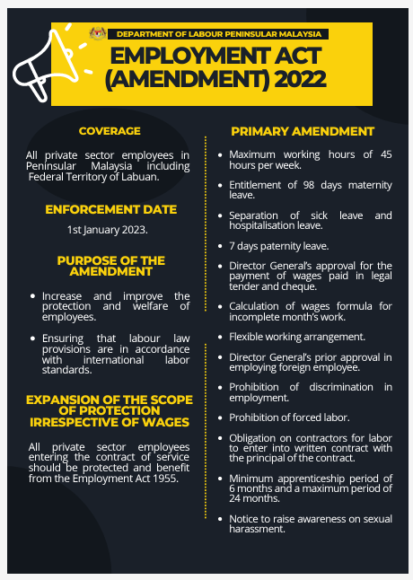

Source: <https://jtksm.mohr.gov.my/sites/default/files/2023-02/Employment%20Act%20%28Amendment%29%202022%20.pdf>